M.NAVEEN
192411134
COURSE CODE – CSA0652

CO5 ASSESSMENT TOOL -2

QUESTION – 1
Design a pseudocode to solve a Sudoku puzzle using Backtracking. Clearly identify inputs (partially filled grid) and output (completed grid). Develop a logically sound algorithm that fills cells while satisfying Sudoku constraints. Use loops and conditional checks effectively for validation. Ensure the pseudocode is well-structured and easy to understand. Handle all possible cases and optimize by skipping invalid placements.

TITLE: SUBSET GENERATION PROBLEM FOR ALL POSSIBLE SUBSETS USING BACKTRACKING

AIM
To generate all possible subsets (Power Set) of a given set using the Backtracking technique.
PROBLEM STATEMENT
Given a set of n elements, generate every possible subset exactly once using recursive include-or-exclude decisions.
INPUT
A set of n elements.
OUTPUT
All possible subsets (Power Set) of the given set.
ALGORITHM
Step 1: Read the number of elements n.
Step 2: Store the elements in an array.
Step 3: Start recursion from index 0.
Step 4: For each element:
a) Include the element in the current subset.
b) Recursively process the next element.
c) Remove the element (Backtrack).
d) Exclude the element and continue recursion.
Step 5: When all elements are processed, print the current subset.
Step 6: Repeat until all subsets are generated.
ADVANTAGES
• Generates all subsets systematically.
• Easy to implement using recursion.
• Demonstrates the Backtracking paradigm effectively.
APPLICATIONS
• Power set generation.
• Feature selection in Machine Learning.
• Combinatorial optimization.
• Decision-making problems.

RESULT
Thus, all possible subsets of the given set were generated successfully using Backtracking.

CODE :-
#include <stdio.h>
#define N 9
int isSafe(int grid[N][N], int row, int col, int num)
{
int x, y;
for(x=0;x<9;x++)
if(grid[row][x]==num)
return 0;
for(x=0;x<9;x++)
if(grid[x][col]==num)
return 0;
int startRow=row-row%3;
int startCol=col-col%3;
for(x=0;x<3;x++)
for(y=0;y<3;y++)
if(grid[startRow+x][startCol+y]==num)
return 0;
return 1;
}
int solveSudoku(int grid[N][N])
{
int row,col,found=0;
for(row=0;row<9;row++)
{
for(col=0;col<9;col++)
{
if(grid[row][col]==0)
{
found=1;
goto END;
}
}
}

END:
if(!found)
return 1;
for(int num=1;num<=9;num++)
{
if(isSafe(grid,row,col,num))
{
grid[row][col]=num;

if(solveSudoku(grid))
return 1;

grid[row][col]=0;
}
}

return 0;
}
void printGrid(int grid[N][N])
{
for(int i=0;i<9;i++)
{
for(int j=0;j<9;j++)
printf("%d ",grid[i][j]);

printf("\n");
}
}
int main()
{
int grid[9][9]={
{3,0,6,5,0,8,4,0,0},
{5,2,0,0,0,0,0,0,0},
{0,8,7,0,0,0,0,3,1},
{0,0,3,0,1,0,0,8,0},
{9,0,0,8,6,3,0,0,5},
{0,5,0,0,9,0,6,0,0},
{1,3,0,0,0,0,2,5,0},
{0,0,0,0,0,0,0,7,4},
{0,0,5,2,0,6,3,0,0}
};
solveSudoku(grid);
printGrid(grid);
return 0;
}

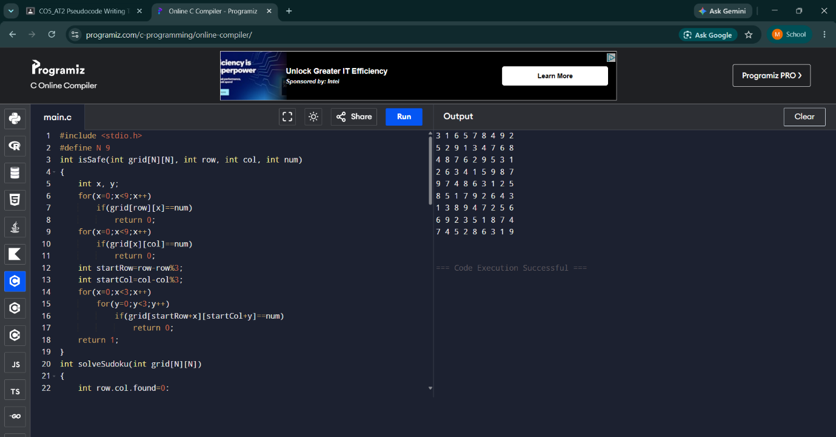

Time Complexity:
O(9^(n×n)) (Worst Case)
Analysis:
For each empty cell, the algorithm may try up to 9 possible digits. If there are many empty cells, the search space grows exponentially. Backtracking reduces unnecessary computations by rejecting invalid placements early.
Space Complexity:
O(n×n)
Analysis:
The recursion stack stores the state of the Sudoku grid while exploring solutions. For a 9×9 Sudoku, the maximum recursion depth depends on the number of empty cells.

CONCLUSION :-
The Sudoku Solver was successfully implemented using the Backtracking technique. The algorithm efficiently fills empty cells while satisfying all Sudoku constraints (row, column, and 3×3 grid rules). By rejecting invalid choices and backtracking when necessary, the puzzle is solved correctly and completely.

